CO4_AT1- Code Challenge
Name: Lavanya
Regno: 192521271
Course name: Design and analysis of algorithms
Course code: CSA0613
Question 23

Title
Minimum Number of Jumps Using Greedy Algorithm
Objective
To find the minimum number of jumps required to reach the last index of an array, where each element represents the maximum number of steps that can be taken forward.
Problem Statement
Given an array of positive integers, determine the minimum number of jumps required to reach the last index.

Source Code:
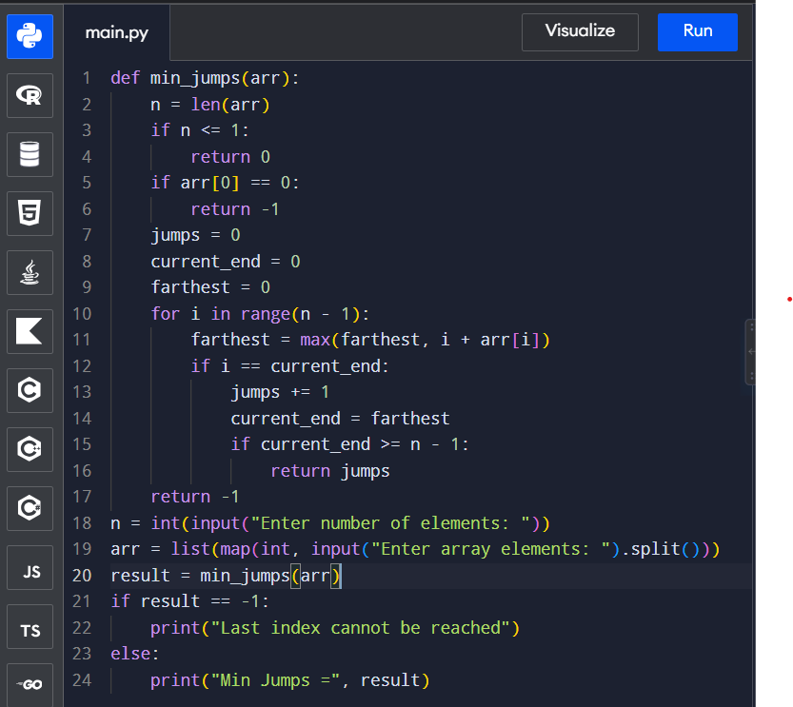

Input & Output:
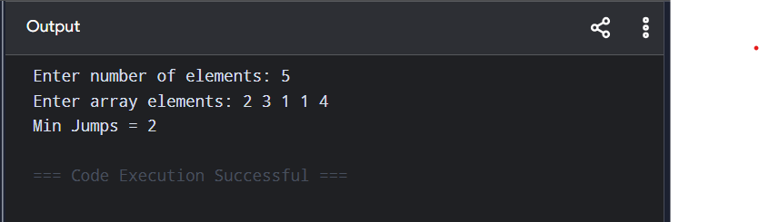

Complexity
- Time Complexity: O(n)
- Space Complexity: O(1)
Complexity
- Time Complexity: O(n)
- Space Complexity: O(1)

